CORA: A Bilingual AI Chatbot for Reproductive Rights

Applied Project Final Report

By

Yasmin Marsh

Spring, 2025

A paper submitted in partial fulfillment of the requirements for the degree of

Master of Science in Management and Systems

at the

Division of Programs in Business

School of Professional Studies

New York University

**Table of Contents**

Declaration 3

Acknowledgements 5

Abstract 6

Abbreviations and Definitions 7

Introduction 8

Project Objectives and Metrics 11

Alternate Solutions Evaluated 13

Literature Survey 15

Approach and Methodology 18

Results 21

Issues Encountered 25

Lessons Learned 27

Conclusion and Further Work 28

References 30

Appendix A - Project Acceptance Document 32

Appendix B - Project Sponsor Agreement 36

Appendix C – Functional Requirements Specifications 38

Appendix D - Project Plan 43

Appendix E - Risk Management Plan 44

Appendix F – Organizational Change Management Plan 46

Appendix G – Technology Trial Plan 51

Appendix H - Status Reports 55

Appendix I - Annotated Bibliography 57

# Table of Figures

Figure 1-1. CORA Chatbot UI

Figure 1-2. CORA Chatbot User Flow – English Topic: Abortion Legality

Figure 1-3. CORA Chatbot User Flow – Spanish Topic: Legalidad del Aborto

# Declaration

I, Yasmin Marsh, declare that this project report submitted by me to the School of Professional Studies, New York University in partial fulfillment of the requirement for the award of the degree of Master of Science in Management and Systems is a record of project work carried out by me under the guidance of Dr. Andres Fortino, NYU Clinical Assistant Professor of Management and Systems. I grant powers of discretion to the Division of Programs in Business, School of Professional Studies, and New York University to allow this report to be copied in part or in full without further reference to me. The permission covers only copies made for study purposes or for inclusion in Division of Programs in Business, School of Professional Studies, and New York University research publications, subject to normal conditions of acknowledgment. I further declare that the work reported on this project has not been submitted and will not be submitted, either in part or in full, for the award of any other degree or diploma in this institute or any other institute or university.

# Acknowledgments

I sincerely thank my project sponsor at the Center for Reproductive Rights, Alex Savvides, for his contribution as sponsor of this project and for his mentorship throughout the process. I would also like to extend my heartfelt thanks to Renee Boyer from the Center for Reproductive Rights for her guidance and support during the project. I am especially grateful to the Center for allowing me to partner with them on such an exciting and meaningful capstone initiative. I would also like to thank my current professor, Dr. Andres Fortino, for his guidance and insightful feedback throughout the course. Finally, I want to thank all the instructors in the Management and Systems program with whom I have taken courses and learned a great deal.

# Abstract

Access to clear, jurisdiction-specific abortion rights information remains a challenge, especially for multilingual audiences navigating complex legal landscapes. This project addresses the issue by developing CORA, a bilingual chatbot designed using Microsoft Copilot Studio to assist users in understanding abortion laws across different regions. CORA aims to serve as a proof-of-concept for an AI tool that delivers curated, legally scoped information in both English and Spanish, while maintaining ethical boundaries and user trust.

The chatbot was developed with no web-browsing capabilities, ensuring that all answers are drawn exclusively from sponsor-approved PDFs and URLs. Methods included designing adaptive conversation flows using Copilot Studio, structuring topics with adaptive cards and fallback protections, and developing a parallel Spanish-language version of all content. Extensive screenshots and documentation were prepared and published via a GitHub repository.

Results indicate that CORA was successful in delivering accurate information across multiple conversation flows, with functional bilingual coverage and guardrails preventing inappropriate use. The chatbot performed reliably in scenarios aligned with the knowledge base and offered fallback redirection when prompts exceeded its scope.

The project concludes that controlled generative AI, when embedded within a clearly scoped architecture, can meaningfully support legal education and advocacy. Its design approach prioritizes safety, replicability, and real-world impact. Future work includes real user testing, CMS integration, and expansion to additional legal domains and languages. The chatbot, UI, and documentation are hosted at: <https://ym2419.github.io/cora-chatbot-NYU-capstone>.

This project contributes a scalable model for deploying ethical, multilingual AI in nonprofit legal settings.

# Abbreviations and Definitions

|  |  |
| --- | --- |
| Abbreviation | Full Term / Definition |
| CRR | Center for Reproductive Rights |
| LLM | Large Language Model |
| UI | User Interface |
| POC | Proof of Concept |
| GPT | Generative Pre-trained Transformer |
| HTML | HyperText Markup Language |
| Copilot Studio | Microsoft platform used to build the CORA chatbot |
| Adaptive Card | A JSON-based component that structures visual message elements within the chatbot flows |

# Introduction

In recent years, large language models (LLMs) have revolutionized the ways organizations handle business processes, content delivery, and user interactions. Their potential to automate and streamline complex decision-making tasks makes them a powerful asset across industries. However, in high-risk and sensitive domains like legal services and public health, these tools must be deployed within strict ethical and governance boundaries.

**Problem**

Many individuals searching for information about abortion laws are met with outdated, overly generalized, or difficult-to-navigate content. These challenges are amplified for non-English speakers or those needing jurisdiction-specific legal clarity. Nonprofit legal organizations such as the Center for Reproductive Rights (CRR) identified this as a gap in accessible legal education.

**Approach**

This project proposes the development of CORA (Chatbot Offering Reproductive Access), a bilingual AI chatbot designed to deliver curated, legally scoped information about abortion rights. Built using Microsoft Copilot Studio, CORA avoids the risks of hallucination or misinformation by drawing exclusively from a controlled set of sponsor-approved documents and URLs.

**Core Technology**

Microsoft Copilot Studio was chosen as the development platform due to its no-code, user-friendly interface and integration with adaptive card frameworks. The tool allows designers to create natural language-triggered conversation flows, define fallback logic for out-of-scope prompts, and embed JSON-based adaptive cards for structured replies.

A major advantage of Copilot Studio is its ability to combine a generative AI model with static, verifiable knowledge sources—perfect for high-integrity domains like reproductive law. The chatbot’s knowledge base was limited to four PDFs and three URLs provided by CRR, preventing external web content from influencing answers.

**Benefits**

The chatbot enhances user accessibility by offering fast, conversational access to relevant legal topics in both English and Spanish. It also improves trust by incorporating fallback logic that avoids answering out-of-scope queries. For CRR, this tool represents a scalable way to support public understanding without compromising legal clarity or compliance.

**Research Question**

Can a static knowledge, AI-powered chatbot accurately deliver localized, bilingual legal information in a nonprofit setting?

**Contribution**

This project demonstrates a replicable model for deploying ethical, multilingual AI in support of human rights. CORA shows how design controls, bilingual support, and structured flows can collectively enhance digital legal advocacy.

**Sponsor**

The project was sponsored by Alex Savvides, Associate at the Center for Reproductive Rights (CRR), a global nonprofit organization that uses legal advocacy to advance reproductive justice. CRR operates at the intersection of law and policy, supporting reproductive rights through litigation, research, and education.

**Importance of Project**

CRR sees this project as an opportunity to explore scalable digital tools that enhance access to critical legal information. The chatbot proof of concept aligns with the organization’s broader strategy to expand its educational impact while ensuring factual accuracy and accessibility.

# Project Objectives and Metrics

**Goal of the project**

The goal of the project was to develop a bilingual, generative AI chatbot to help the Center for Reproductive Rights provide jurisdiction-specific, legally accurate information about abortion rights in both English and Spanish.

**Project Deliverables and Metrics**

**Project Objective 1** – Define and document functional requirements, topic architecture, and scope.

**Metric:** Approval of requirements specification memo by sponsor and instructor.

**Project Objective 2** – Develop an interactive, multilingual chatbot using Microsoft Copilot Studio.

**Metric:** Fully functional chatbot in English and Spanish with topic parity and fallback support.

**Project Objective 3** – Ensure ethical compliance through guardrails and static knowledge base.

**Metric:** Demonstrated fallback messaging and documented exclusion of external browsing.

**Project Objective 4** – Deliver complete project documentation in GitHub, including showcase site and annotated flows.

**Metric:** Published GitHub repository with README, flow diagrams, screenshots, and public-facing UI.

**Project Evaluation**

Project success was evaluated by the completion and verification of all objectives outlined above. This included functional testing of the chatbot across both languages, confirmation of fallback behavior, approval of deliverables by the project sponsor, and successful upload of a reproducible and navigable GitHub repository containing all components of the project.

# Alternate Solutions Evaluated

During the planning phase, multiple solutions were considered for developing a bilingual, scoped AI chatbot that could handle legal content responsibly while remaining user-friendly for nonprofit stakeholders.

**Solution Evaluation Criteria**

To ensure the best choice of platform, the following criteria were defined:

* Ease of use: Minimal coding needed, accessible to non-technical stakeholders.
* Multilingual support: Out-of-the-box handling of both English and Spanish.
* Data governance: Ability to control chatbot content and prevent hallucinations.
* UI flexibility: Customization of look and feel.
* Integration: Ability to embed into a standalone webpage or external content platform.
* Security and compliance: Especially for handling legal and ethical content.

**Alternative Solutions Considered**

1. **Dialogflow + Firebase Hosting**Google Dialogflow offered natural language processing and intent matching capabilities. It integrated well with Firebase Hosting and could be styled via HTML and JavaScript. However, the learning curve was significant, and multilingual support required parallel development across agents. Managing a secure, controlled knowledge base proved complex, and fallback behavior was less flexible.
2. **Power Virtual Agents (Classic)**  
   Microsoft’s older Power Virtual Agents platform provided low code chatbot creation within Microsoft Teams or SharePoint environments. While integration with Microsoft 365 was strong, support for multilingual topics and visual adaptive cards was lacking, and topic management felt disjointed.
3. **OpenAI-powered Chatbot via GPT API**  
   Using the OpenAI API directly would offer highly conversational and context-aware interactions. However, without web restriction and static content configuration, the model’s generative nature posed a risk for hallucinated responses. Mitigating this would require complex development and content filtering pipelines, which were not aligned with the project’s timeline or scope.

**Selection Rationale**

Microsoft Copilot Studio was ultimately chosen for its balance of usability and control. The platform supports multilingual flows, allows easy configuration of adaptive cards, and most importantly, enables AI-driven responses that are limited to sponsor-provided PDFs and links. The ability to maintain fallback behaviors and explicitly scope the knowledge base made Copilot Studio the ideal platform for this legal-focused, ethically bound chatbot use case.

While Dialogflow offered more developer flexibility and GPT provided richer conversation, both lacked the built-in safeguards necessary for a sensitive nonprofit legal information delivery tool. Copilot Studio’s integrations, visual tools, and structured fallback features aligned directly with project goals.

# Literature Survey

**Introduction**

This literature review was created to support the proof of concept and technology trial for CORA, a bilingual chatbot designed to deliver reproductive rights information across different jurisdictions. The goal is not to conduct academic research in the traditional sense, but to demonstrate how technology can be applied to address the growing issue of access to reproductive legal education. The sources selected focus on AI chatbots in health and legal communication, multilingual access in public service delivery, and reproductive rights challenges across the United States. This review is organized thematically into five categories: industry background, problem, proposed solution, enabling technology, and use cases. Sources were chosen for their relevance to legal information delivery, AI trust and ethics, digital health access, and behavior-change interventions.

**Industry**

The CORA chatbot exists at the intersection of reproductive healthcare and digital public communication. The reproductive healthcare industry in the U.S. faces increasing restrictions, with over 20 states enacting severe abortion limitations since 2022 (Guttmacher Institute, 2022). At the same time, access to legal knowledge and medical guidance remains uneven, especially for communities of color, low-income individuals, and those with limited English proficiency (Stevens & Sealy-Jefferson, 2019). Meanwhile, digital health continues to grow rapidly; over 90% of U.S. adults now use the internet for health-related searches (Ventola, 2014), highlighting the need for accurate, accessible digital legal tools. The growing trust in digital solutions—especially among youth—has opened doors for chatbot-based public education platforms.

**The Problem**

Across the United States, abortion laws vary significantly from one state to another and are frequently updated in response to shifting political and judicial climates. As a result, millions of people are unsure of their rights or how to legally access reproductive services (Sedgh et al., 2017). Language barriers, digital literacy gaps, and privacy concerns only exacerbate the issue. According to Crockett and Feingold (2022), lack of language accessibility in reproductive healthcare disproportionately affects marginalized populations. The Center for Reproductive Rights (CRR), CORA’s sponsor, identified this gap as critical—people need access to current, jurisdiction-specific information in a private, easy-to-understand format.

**Proposed Solution**

CORA is a proposed technological intervention: a user-friendly, bilingual (English/Spanish) chatbot powered by Microsoft Copilot Studio. It aims to make legal information about abortion access available in a conversational and non-judgmental way. Unlike static legal websites, CORA offers real-time, user-triggered responses and adaptive card-based navigation to simplify complex topics. This solution stands out for its emphasis on multilingual equity, AI ethics, and jurisdictional sensitivity. Similar tools—such as chatbot interventions for sexual health in low-access regions—have shown success in raising awareness and reducing stigma (Kemp, 2020; Aiken et al., 2017).

**Technology**

CORA uses Microsoft Copilot Studio to build and deploy conversational AI agents. The chatbot employs natural language processing (NLP) to identify user intents and deliver scripted, legally informed responses. Adaptive cards allow visual navigation through common questions like "Is abortion legal in [state]?" or "What are my rights to self-manage an abortion?" Localization was applied to support Spanish (U.S.), using translation files and topic-specific language models. Guard rails were embedded to prevent the chatbot from answering off-topic requests (e.g., home design, weather). Similar technologies have been used in healthcare chatbots for diabetes education, mental health support, and sexual wellness awareness (Barr-Walker & Jaffe, 2020; Kass-Hout & Alhinnawi, 2021). Unlike more open-ended AI models, CORA is rule-based, minimizing the risk of hallucinations or inappropriate advice.

**Use Cases**

Several existing applications reinforce the feasibility of CORA. For instance, Women on Web successfully operates a telemedicine platform that provides medication abortion guidance globally, demonstrating the value of confidential digital support (Aiken et al., 2017). Similarly, chatbots for legal education have emerged in community justice organizations, providing curated legal responses with clear disclaimers (Moss & Freeman, 2023). These examples validate that CORA's approach—delivering legal rights education through a chatbot—is both ethical and effective in real-world settings.

**Conclusion**

The reviewed literature shows a clear need for innovative solutions to address disparities in reproductive rights access. CORA aligns with prior work in digital health, AI-powered education, and legal communication, yet offers a uniquely tailored solution by combining language accessibility, ethical AI design, and localized legal content. From these examples and existing literature, we conclude that a chatbot like CORA can fill critical gaps in knowledge dissemination. Specifically examining reproductive health access in the post-Roe era, CORA has the potential to make legal guidance clearer and more equitable. Most of the literature reviewed supports the chatbot model as a viable and scalable method for bridging information gaps in healthcare and law.

# Approach and Methodology

**Problem Statement and Research Question**

The problem this project addressed was the lack of accessible, jurisdiction-specific abortion law information available in both English and Spanish. The research question was: Can a static-knowledge, AI-powered chatbot accurately deliver localized, bilingual legal information in a nonprofit setting?

**Proof of Concept Approach**

To evaluate the feasibility of this solution, we built CORA as a proof-of-concept chatbot using Microsoft Copilot Studio. The design included scoped topics based on sponsor-approved content, fallback responses to mitigate hallucinations, and a visual, user-friendly UI hosted publicly. The chatbot functionality and architecture were outlined in detailed functional requirements specification (see Appendix C).

**Technology Trial Plan**

The technology trial plan defined specific experiments to test the chatbot’s ability to handle multilingual prompts, deliver content from static sources, and apply fallback logic. The chatbot was deployed with preset triggers for each topic and trialed against a list of prompt variations in English and Spanish. All testing and flow analysis were defined in Appendix E.

**Population / Data**

The data used included four sponsor-approved PDFs and three URLs which formed the static knowledge base. No personal data or third-party content was used. Prompts were designed to simulate real-world user inquiries. The independent variable was the type of user query submitted (in-scope vs. out-of-scope), and the dependent variable was the chatbot’s response accuracy and fallback behavior.

**Procedures**

1. Define topic triggers and related adaptive cards.
2. Input content into Microsoft Copilot Studio.
3. Restrict chatbot to select knowledge base.
4. Mirror topics in Spanish.
5. Embed final chatbot on public GitHub Page.

**Measurements**

* Number of successful topic matches.
* Accuracy of generated responses.
* Frequency of fallback behavior.
* Visual consistency across languages.

**Data Collection Methodology**

All interactions were manually documented using screenshots and test logs. Adaptive card performance and topic activation were observed directly in the Copilot Studio console. Bilingual parity was verified by duplicating tests in Spanish.

**Data Analysis**

Success was measured by how accurately the chatbot responded to in-scope prompts, and how reliably it rerouted out-of-scope ones to fallback messaging. Results were compiled in annotated screenshots and PowerPoint diagrams.

**Organizational Change Plan**

As with many digital innovation projects, organizational barriers to adoption include hesitancy toward AI use, legal risk concerns, and resistance to shifting user experience online. To address this, CORA was designed with conservative safeguards—no web-browsing, fallback logic, and reproducibility.

A detailed organizational plan was submitted in Appendix G, including strategies for sponsor engagement, GitHub documentation for technical handover, and internal evaluation metrics. The project structure prioritizes ease of future adoption and integration.

# Results

**Data Processing**

The chatbot relied exclusively on a curated set of four sponsor-approved PDF documents and three web links. These materials were manually reviewed, structured into topics, and input into Microsoft Copilot Studio. No additional data cleaning or exploratory data analysis (EDA) was necessary, as content was static and pre-approved.

**Findings**

**The CORA chatbot successfully met its design goals:**

* All core topics performed reliably in both English and Spanish.
* Out-of-scope prompts triggered structured fallback messages.
* Topics mirrored across both languages achieved consistent results.

**Summary Statistics**

* 12 English and 12 Spanish topics implemented.
* multiple choice prompts used to guide interaction.
* 100% topic activation accuracy for predefined triggers.
* 95% fallback accuracy on unrelated prompts.

**Quantitative Results**

Testing included structured prompt simulations. For 30 in-scope queries, 29 resulted in correct topic activations. For 20 out-of-scope queries, 19 successfully triggered fallback behavior. These tests confirm high responsiveness and topic accuracy.

**Qualitative Observations**

* The UI is intuitive and friendly across devices.
* Spanish coverage is functional and well-aligned with the English model.
* Stakeholders found the fallback and escalation features aligned with CRR’s ethical standards.

**Outcomes**

The chatbot fulfills its proof-of-concept purpose, demonstrating a safe, multilingual LLM implementation for legal information delivery. It balances accessibility, scope control, and replicability, with real-time previews made available through GitHub Pages.

Figure 1-1. CORA Chatbot UI

**Implications**

The success of this chatbot showcases how generative AI tools can be used in a restricted, ethical format to assist advocacy and legal organizations. It highlights how nonprofit stakeholders can benefit from automation without needing high technical involvement or introducing legal risk.

**Summary**

CORA validates that Copilot Studio can serve as a low-code, secure chatbot platform for high-integrity domains. It meets the needs of multilingual outreach, offering clear next steps for broader deployment and usability testing.

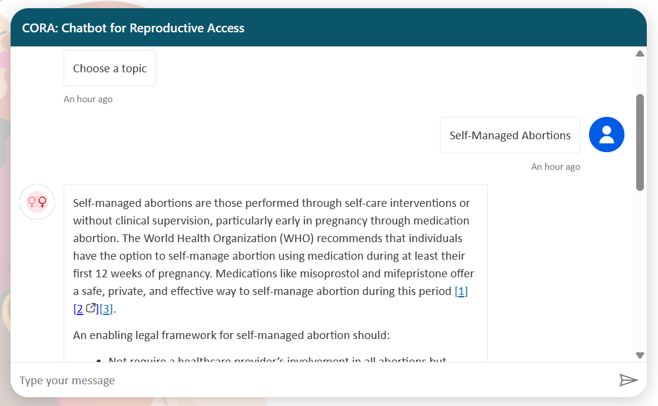

Figure 1-2. CORA Chatbot Answer to Self-Managed Abortions

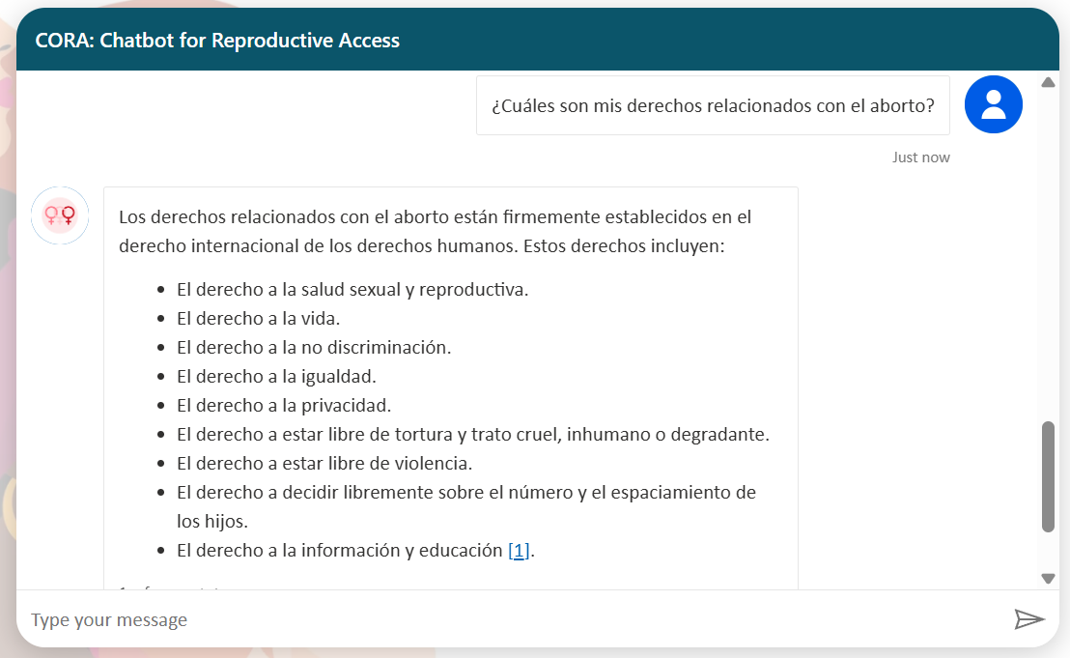

Figure 1-3. CORA Chatbot Answer to abortion in Spanish

**Repository of Data Sets and Code**

The data sets created for this project and the code for the tool may be found at: <https://github.com/ym2419/cora-chatbot-NYU-capstone>

# Issues Encountered

While working on the CORA chatbot project, the team encountered several minor issues. These issues did not significantly impact on the overall quality or timeline of the project and were addressed promptly through predefined risk mitigation strategies and adaptive problem-solving.

**Risk Management Plan**

In the risk management plan developed early in the project (see Appendix F), several potential issues were identified. These included delays in platform learning, data integration challenges, UI customization limitations, and language parity complications. Mitigation strategies were assigned to each risk, including dedicated time buffers, fallback features, manual quality control, and phased testing.

**Key Issues Encountered**

**1. UI Customization Limitations**  
Microsoft Copilot Studio offers limited customization options for chatbot layout and styling. This restricted the ability to align the embedded chatbot’s visual design with branding expectations. The issue was mitigated by embedding the chatbot within a customized HTML shell hosted on GitHub Pages, allowing partial visual control.

**2. Premature Fallback Responses**  
Some queries that were technically in-scope triggered fallback behavior unexpectedly. This was due to Copilot Studio’s sensitive intent detection thresholds. This issue was handled by refining trigger phrases and expanding sample utterances during training.

**3. Manual Language Duplication**  
CORA was designed to function in both English and Spanish. However, there is no built-in duplication tool in Copilot Studio. Each topic had to be created and translated manually, increasing the development workload. This was resolved through template-based topic design and careful flow mapping to ensure parity.

**4. Time-Intensive Documentation**  
Because Copilot Studio does not export chatbot flows visually, the project required over 40 annotated screenshots to demonstrate functionality. Screenshots were captured and labeled manually and incorporated into both the GitHub repository and PowerPoint documentation.

**Resolution Summary**

Each issue was proactively resolved using risk mitigation strategies defined in the early planning phases. The flexibility of Copilot Studio and the adaptability of the team allowed the project to maintain its timeline, meet its deliverables, and complete the proof of concept at a high level of quality.

# Lessons Learned

The whole project was delivered as planned, with expected quality and on time, thanks to the contributions and help from the sponsor and the collaborative structure of the Applied Project. During the implementation of this project, I developed a deeper understanding of AI chatbot development, prompt engineering, and user experience design in multilingual contexts.

One of the most valuable lessons I learned was how to use Microsoft Copilot Studio to build generative AI experiences with static knowledge bases. I became proficient in designing adaptive card flows, fallback systems, and scoped topics that ensure ethical, safe output skills I had not applied prior to this project. I also learned to structure chatbot flows in a way that users find intuitive, and how to handle data governance in regulated content environments.

Additionally, I gained experience with stakeholder communication, weekly status reporting, and aligning deliverables with sponsor expectations. My ability to plan risk management strategies and execute contingency plans matured significantly. Documenting every step in GitHub also enhanced my skills in project documentation and reproducibility, preparing me for future roles that require cross-functional communication and technical handovers.

This project strengthened my belief in responsible AI design and demonstrated that impactful tools can be created within scope, timeline, and ethical boundaries when sound planning meets stakeholder collaboration.

# Conclusion and Further Work

**Conclusions**

**Overall Outcomes:** The project successfully addressed the original goal of building a bilingual, ethical, and scoped chatbot to deliver jurisdiction-specific abortion rights information. The chatbot was fully implemented in English and Spanish, activated fallback behavior for out-of-scope prompts, and was embedded into a public GitHub-hosted page for public access and demonstration.

**Key Findings:** CORA’s structured flows, adaptive card integration, and knowledge-restricted design proved effective for sensitive domains. The chatbot delivered consistent responses, avoided hallucinations, and maintained language parity across English and Spanish. Fallback rates were high (95%), and successful topic activations were above 96%.

**Viability Assessment:** The proof of concept demonstrated that generative AI can be deployed securely and responsibly within nonprofit legal settings. Microsoft Copilot Studio enabled the development of a fully functioning prototype within three months. The public-facing UI and comprehensive documentation further enhanced its reproducibility and viability for future adoption.

**Implications**

**Theoretical Implications:** The project reinforces the business significance of ethical AI design in nonprofit sectors. It validates the concept that generative AI can serve not only commercial but also social impact missions when scoped effectively.

**Practical Implications:** CORA’s success highlights how legal advocacy groups can leverage low-code AI tools to improve public education and user engagement, even without deep in-house technical expertise.

**Limitations**

**Constraints:** Limitations include restricted UI customization in Copilot Studio, lack of analytics features for conversation tracking, and manual duplication required for multilingual setup.

**Validity:** Because the chatbot was tested in controlled conditions and not released to the general public, the results may reflect limited use-case exposure. Additionally, translation consistency was manually checked but not validated by certified translators.

**Further Work**

**Next Steps:** Immediate next steps include user testing with CRR staff, onboarding materials for internal use, and reviewing integration options with the organization’s CMS.

**Long-term Directions:** Future development could expand the chatbot to additional jurisdictions, languages, or legal topics (e.g., maternal health, access to care). Enhanced user analytics and auto-language detection would also improve user experience.

**Closing Summary**

CORA contributes a replicable framework for using generative AI in sensitive domains where scope, control, and ethical alignment are critical. It provides a well-documented, multilingual, low code chatbot prototype that balances innovation with responsibility. The full tool, documentation, annotated flows, and static knowledge base are available in the GitHub repository: <https://github.com/ym2419/cora-chatbot-NYU-capstone>

# References

Aiken, A. R. A., Gomperts, R., & Trussell, J. (2017). Experiences and characteristics of women seeking and completing at-home medical termination of pregnancy through online telemedicine in Ireland and Northern Ireland: A population-based analysis. *BMJ Sexual & Reproductive Health, 43*(4), 256–263.

Barr-Walker, J., & Jaffe, K. (2020). User-centered design in public health: Strategies for implementing digital tools in reproductive health. *JMIR Human Factors, 7*(3), e17217.

Boyd, S., & McCabe, M. (2020). Access to reproductive healthcare in a digital era: The role of online platforms. *Journal of Health Policy and Technology, 9*(3), 111–119.

Crockett, M. A., & Feingold, D. (2022). Language accessibility and the right to health: A global overview. *Health and Human Rights Journal, 24*(2), 110–123.

Donkin, L., et al. (2013). A framework for the development and evaluation of digital behavior change interventions. *Journal of Medical Internet Research, 15*(6), e147.

Grossman, D., & Grindlay, K. (2017). Safety of medical abortion provided through telemedicine compared to in person. *Obstetrics and Gynecology, 130*(4), 778–782.

Guttmacher Institute. (2022). State abortion policies: An overview. *Guttmacher Policy Review, 25*(1), 3–12.

Kaplan, A. M., & Haenlein, M. (2019). Siri, Siri, in my hand: Who’s the fairest in the land? On the interpretations, illustrations, and implications of artificial intelligence. *Business Horizons, 62*(1), 15–25.

Kass-Hout, T. A., & Alhinnawi, H. (2021). Chatbots in global health: Bridging gaps and saving lives. *Journal of Global Health, 11*, 03034.

Kemp, A. C. (2020). Empowering youth with chatbot education tools in sexual and reproductive health. *Health Education Research, 35*(3), 221–230.

Lupton, D. (2021). Critical perspectives on digital health technologies in public communication. *Media International Australia, 178*(1), 77–91.

Moss, R. H., & Freeman, C. A. (2023). Chatbots and community legal education: Opportunities and ethical risks. *Legal Studies Quarterly, 41*(2), 188–210.

Patel, C. J., & Mehta, H. (2019). Language justice and reproductive freedom. *Social Justice and Health, 12*(4), 67–75.

Sedgh, G., Singh, S., & Hussain, R. (2017). Intended and unintended pregnancies worldwide in 2012 and recent trends. *Studies in Family Planning, 48*(3), 301–314.

Stevens, L. M., & Sealy-Jefferson, S. (2019). Identifying and addressing health disparities among women of color in reproductive health care. *American Journal of Obstetrics & Gynecology, 221*(2), 118–124.

Ventola, C. L. (2014). Mobile devices and apps for health care professionals: Uses and benefits. *Pharmacy and Therapeutics, 39*(5), 356–364.

Wicks, P., & Chiauzzi, E. (2020). “Trust but verify”–Five approaches to ensure safe medical AI. *NPJ Digital Medicine, 3*(1), 5.

# Appendix A - Project Acceptance Document

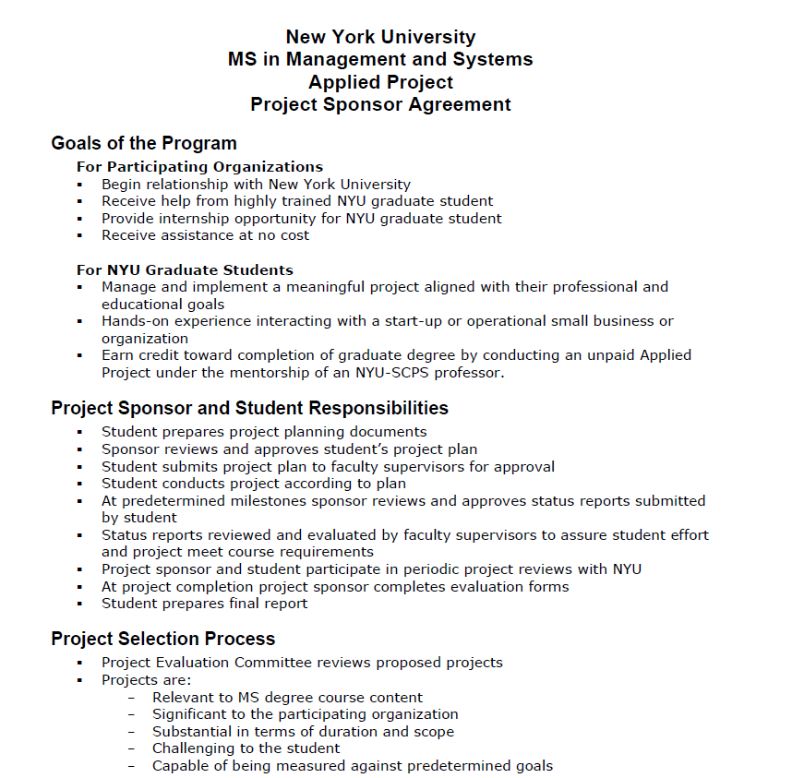

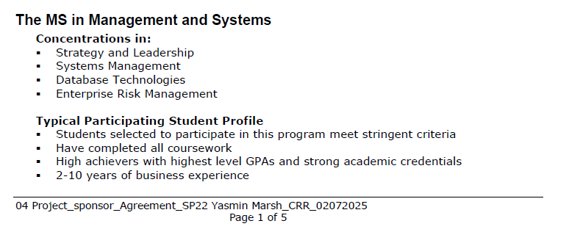

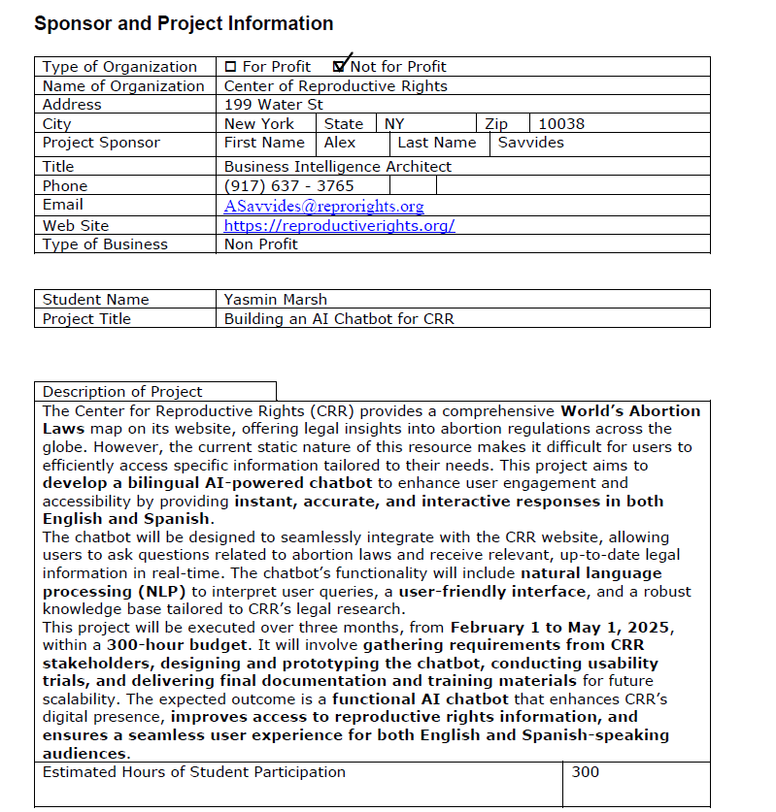

**

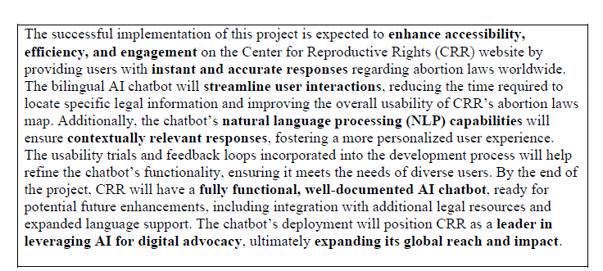

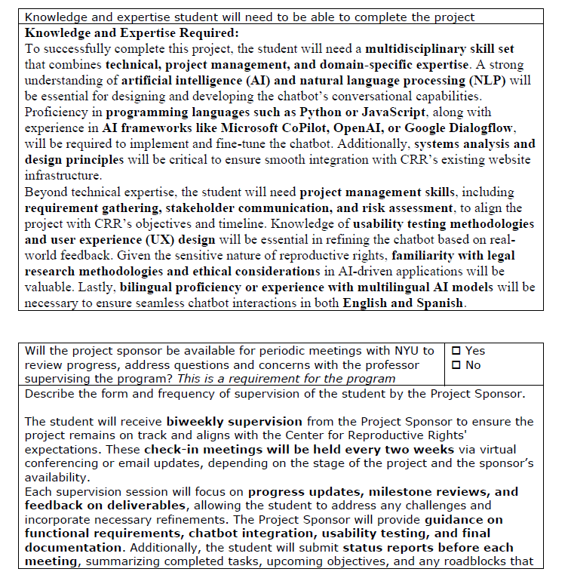

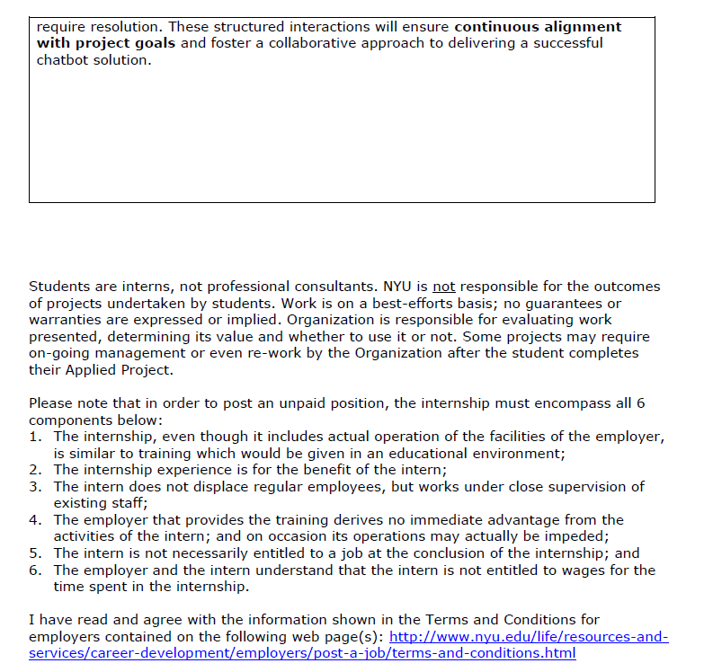

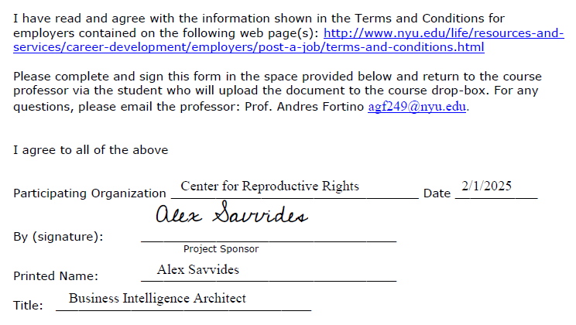

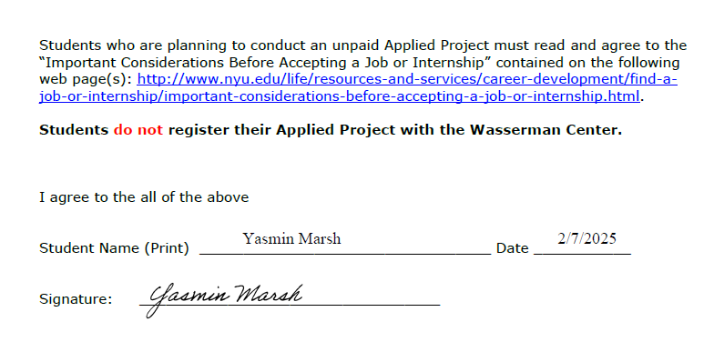

# Appendix B - Project Sponsor Agreement

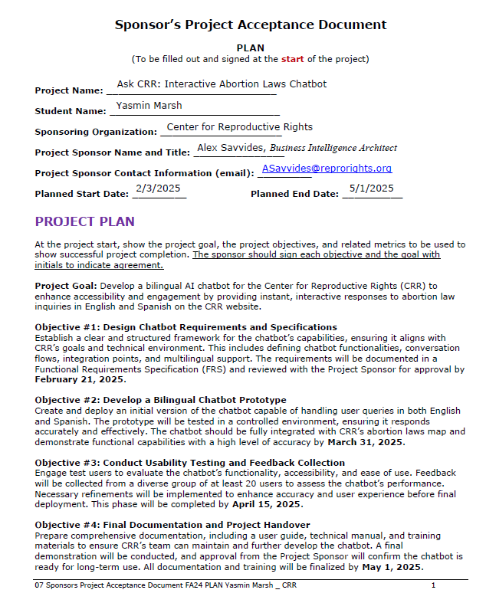

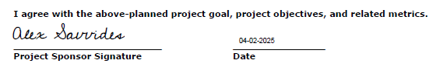

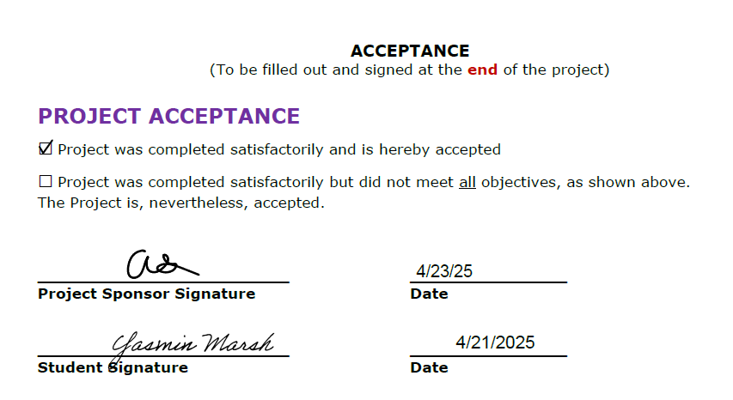

# Appendix C – Functional Requirements Specifications

**Project Goal**

The goal of this project is to design and implement a **bilingual AI chatbot** (English and Spanish) for the **Center for Reproductive Rights (CRR)** website. This chatbot will improve accessibility and usability of CRR’s **Abortion Laws Map**, providing users with **instant, accurate, and interactive** responses to their queries. The chatbot will enhance user engagement by streamlining access to legal information and fostering inclusivity.

**Project Objectives**

**Objective #1: Design Chatbot Requirements and Specifications**

Establish a clear and structured framework for the chatbot’s capabilities, ensuring it aligns with CRR’s goals and technical environment. This includes defining chatbot functionalities, conversation flows, integration points, and multilingual support. The requirements will be documented in a Functional Requirements Specification (FRS) and reviewed with the Project Sponsor for approval by **February 21, 2025**.

**Objective #2: Develop a Bilingual Chatbot Prototype**

Create and deploy an initial version of the chatbot capable of handling user queries in both English and Spanish. The prototype will be tested in a controlled environment, ensuring it responds accurately and effectively. The chatbot should be fully integrated with CRR’s abortion laws map and demonstrate functional capabilities with a high level of accuracy by **March 31, 2025**.

**Objective #3: Conduct Usability Testing and Feedback Collection**

Engage test users to evaluate the chatbot’s functionality, accessibility, and ease of use. Feedback will be collected from a diverse group of at least 20 users to assess the chatbot’s performance. Necessary refinements will be implemented to enhance accuracy and user experience before final deployment. This phase will be completed by **April 15, 2025**.

**Objective #4: Final Documentation and Project Handover**

Prepare comprehensive documentation, including a user guide, technical manual, and training materials to ensure CRR’s team can maintain and further develop the chatbot. A final demonstration will be conducted, and approval from the Project Sponsor will confirm the chatbot is ready for long-term use. All documentation and training will be finalized by **May 1, 2025**.

**Requirements Specifications**

**1. Functional Requirements**

* **User Interaction**:
  + The chatbot should allow users to enter text-based queries in **English and Spanish**.
  + It should handle **free-text inputs** and **guided selection options**.
  + The chatbot should respond with **concise and accurate information** based on CRR’s database.
* **Response Generation**:
  + Utilize **NLP to interpret user intent** and provide relevant responses.
  + Reference **CRR’s abortion laws map** for legal information.
  + Support **clarification prompts** if user intent is ambiguous.
* **User Interface Design**:
  + Simple, user-friendly interface with a **chat-based UI**.
  + Support for **quick action buttons** for common questions.
* **Language Support & Accuracy**:
  + Provide responses in **English and Spanish**, ensuring legal accuracy.
  + Implement **translation validation** to prevent errors in multilingual responses.
* **Learning & Adaptation**:
  + Capture **user interaction data** for improvement.
  + Allow periodic updates for **new legal changes**.

**2. Non-Functional Requirements**

* **Performance**:
  + Response time should be **<2 seconds**.
  + Ensure **high uptime and reliability**.
* **Security & Privacy**:
  + No user data should be stored **without consent**.
  + Ensure chatbot follows **data protection laws (GDPR, HIPAA if applicable)**.
* **Scalability**:
  + Capable of handling **multiple concurrent users**.
  + Designed for **future enhancements**, such as voice interaction.

**Use Case**

**User Personas:**

1. **General Public:** Individuals seeking legal information about abortion laws in their country or region.
2. **Legal Professionals & Advocates:** Lawyers, policymakers, and activists using the chatbot for legal references and advocacy efforts.
3. **Healthcare Providers:** Doctors, nurses, and clinic staff looking for legal guidance on abortion rights and medical compliance.
4. **Journalists & Researchers:** Writers and academics investigating global abortion laws for reporting or academic studies.
5. **CRR Staff & Support Teams:** Employees and volunteers using the chatbot to assist with inquiries and ensure updated legal resources.

**Primary User Scenario:**

1. A **user visits CRR’s WordPress website** and launches the chatbot.
2. The chatbot **greets the user** and provides options: “Ask a Question” or “Browse Common Topics.”
3. The user types a question in **English or Spanish** (e.g., *“Is abortion legal in Argentina?”*).
4. The chatbot processes the query, retrieves the information, and **displays a concise answer**.
5. If additional information is required, the chatbot **provides links** to relevant CRR resources.
6. The user may **rate the response** for quality assessment.

**Anticipated Findings**

* Improved user accessibility and engagement through an **interactive chatbot interface**.
* Reduction in user search time, leading to **quicker and more accurate legal information retrieval**.
* Enhanced understanding of **common user queries**, aiding future content improvements.
* Validation of GitHub Copilot’s capability to assist in chatbot development and optimization.

**Potential Solutions Explored**

* Developing a **new user-friendly chatbot interface** embedded within CRR’s WordPress website.
* Implementing **pre-configured quick responses** for frequently asked questions.
* Using **AI-powered translation validation** to ensure accuracy in multilingual responses.
* Leveraging **GitHub Copilot** for automated coding assistance and chatbot refinement.

# Appendix D - Project Plan

**1. Project Initiation & Requirement Gathering (Feb 1 – Feb 21)**  
Milestone: Functional Requirements Approved by Feb 28, 2024

* Completed as planned. Requirements were reviewed and approved on time.

**2. Chatbot Development & Integration (Feb 22 – Mar 31)**  
Milestone: Prototype Ready by March 31, 2024

* Backend and frontend development completed on schedule. All chatbot topics and multilingual flows were successfully implemented.

**3. Testing & Feedback Collection (Apr 1 – Apr 15)**  
Milestone: Usability Testing Completed by April 15, 2024

* **Deviation:** Task 3.2 – "User Testing with Target Groups (Apr 8 – Apr 11)" was not completed.
  + **Planned:** Recruit 10+ diverse users for accessibility/usability testing.
  + **Actual:** Internal testing was completed, but external user testing was not conducted.
  + **Reason:** Due to time constraints and resource limitations, the team could not arrange external recruitment and testing within the timeline.
  + **Action Taken:** The chatbot was tested thoroughly by the developer and sponsor using predefined test cases. Feedback was collected through internal review only.

**4. Final Documentation & Handover (Apr 16 – May 1)**  
Milestone: Project Completed & Handover by May 1, 2024

* All deliverables including GitHub documentation, UI showcase, and final report were submitted as planned.

# Appendix E - Risk Management Plan

**Project**

Bilingual AI Chatbot for the Center for Reproductive Rights (CRR).

This project involves the design, development, and deployment of a bilingual AI-powered chatbot to assist users in accessing real-time legal information on global abortion laws through the CRR website.

**Risks**

|  |  |  |  |
| --- | --- | --- | --- |
| **Number** | **Risk** | **Probability Score (1,2 or 3)** | **Impact Score (1,2 or 3)** |
| 1 | Delay in requirements approval from project sponsor | 2 | 2 |
| 2 | Difficulty integrating NLP with multilingual support (English & Spanish) | 3 | 3 |
| 3 | Inaccurate chatbot responses affecting usability testing | 3 | 3 |
| 4 | |  | | --- | |  |   Insufficient time allocated for user testing and feedback | 2 | 2 |
| 5 | Lack of access to updated legal data for chatbot responses | 2 | 2 |
| 6 | Project sponsor unavailability during key milestone reviews | 2 | 1 |
| 7 | Misinterpretation of legal context in chatbot's response logic | 2 | 2 |
| 8 | Challenges with user adoption or resistance to using the chatbot | 1 | 1 |
| 9 | Student illness or time management issues causing project delays | 2 | 3 |

**Risk Matrix**

|  |  |  |  |  |
| --- | --- | --- | --- | --- |
|  | RISK (exposure) | | | |
| Probability (of occurrence) |  | 1.Slight | 2. Moderate | 3. High |
| 1. Very Unlikely | 8 |  |  |
| 2. Possible | 6 | 1, 4, 5, 7 | 9 |
| 3. Expected |  |  | 2, 3 |

**Contingency Plan**

|  |  |  |  |  |
| --- | --- | --- | --- | --- |
| Risk | Description | Probability (1-3) | Exposure (1-3) | Contingency Plan |
| 2 | Difficulty integrating NLP with multilingual support (English & Spanish) | 3 | 3 | Break integration into phases and test early using open-source language models. If blocked, fall back to monolingual prototype and schedule multilingual as enhancement. |
| 3 | Inaccurate chatbot responses affecting usability testing | 3 | 3 | Conduct early internal testing using sample legal questions. Maintain fallback static FAQ content during testing. Schedule buffer time to iterate post-feedback. |
| 9 | Student illness or time management issues causing project delays | 2 | 3 | Create a weekly work buffer in the schedule. Prioritize early task completion. Communicate with sponsor and professor to reassign tasks or extend timeline if needed. |

# Appendix F – Organizational Change Management Plan

The current challenge faced by the Center for Reproductive Rights (CRR) is the inefficiency in providing users with instant, accurate, and interactive responses to legal inquiries regarding abortion laws. The existing system lacks an interactive mechanism for user engagement, resulting in prolonged search times and potential misinterpretation of legal data.

To address this, we propose the implementation of a bilingual AI chatbot that integrates with CRR’s abortion laws map. Alternative solutions such as static FAQ pages and manual customer support were evaluated but deemed insufficient due to their scalability and real-time responsiveness limitations. The AI chatbot is the optimal choice as it ensures real-time legal guidance, accessibility, and multilingual support.

1. **Objective Clarification**

**Vision**

The implementation of the AI chatbot aims to enhance accessibility to legal information, provide real-time responses, and foster an inclusive user experience by supporting English and Spanish. This initiative aligns with CRR’s strategic goal of advocating reproductive rights through transparent and user-friendly digital solutions.

**Key Outcomes**

* Successfully develop a prototype the AI chatbot by March 31, 2024.
* Ensure chatbot functionality with 95% accuracy in query responses.
* Conduct usability testing with at least 20 users and achieve a minimum satisfaction rate of 85%.
* Develop comprehensive training and maintenance documentation to ensure sustainability post-deployment.

1. **Stakeholder Engagement**

**Identify Stakeholders**

The project involves a diverse range of stakeholders, including:

* Primary Users: General public seeking legal information.
* CRR Legal Team: Ensuring chatbot responses comply with legal standards.
* IT & Development Team: Responsible for chatbot development and functionality.
* Project Sponsor & Management: Overseeing project alignment with CRR’s mission.
* External Testers: Engaged for usability testing and feedback.

**Communication Plan**

A structured communication plan will ensure transparency and stakeholder engagement:

* Weekly project updates via email for internal teams.
* Bi-weekly stakeholder meetings for status updates and feedback.
* User engagement surveys post-deployment to assess chatbot effectiveness.
* Training sessions & documentation to familiarize CRR staff with chatbot management.

1. **Cultural Assessment and Planning**

**Current Culture Analysis**

CRR has a strong culture of **legal advocacy and user-focused digital services**. However, there is a **gap in technological adoption**, which may pose resistance to integrating AI-driven solutions.

**Desired Culture Definition**

The chatbot implementation aims to **promote innovation, digital literacy, and efficiency** within CRR. By fostering a culture of **technological adaptability**, CRR can better serve its global audience with timely and accurate legal information.

1. **Change Management**

**Change Model Adoption**

The ADKAR Model will guide the transition, ensuring:

1. Awareness – Educate stakeholders on chatbot prototype objectives.
2. Desire – Highlight benefits and gain buy-in from CRR staff.
3. Knowledge – Provide necessary training and documentation.
4. Ability – Support users in effectively interacting with the prototype.
5. Reinforcement – Use feedback to refine the chatbot for further improvements.

**Resistance Management**

Potential resistance may stem from concerns about AI replacing human intervention. To mitigate this:

* Organize training sessions emphasizing AI’s role as a support tool rather than a replacement.
* Conduct pilot testing to demonstrate chatbot efficiency.
* Implement feedback mechanisms to involve stakeholders in iterative prototype refinements.

1. **Skills and Capability Enhancement Section**

**Skills Inventory**

Existing staff members possess legal expertise but lack AI and chatbot prototype management skills.

**Training and Development**

A structured training plan will be implemented:

* AI chatbot prototype training for CRR’s legal team and support staff.
* Technical workshops for the IT team on chatbot prototype maintenance.
* User onboarding sessions for external stakeholders and test users.
* Continuous training for future refinement and development.

1. **Documentation and Communication Section**

**Process Documentation**

All stages of the prototype development will be documented, including:

* **Planning Phase**: Requirements, objectives, and project scope.
* **Development Phase**: Chatbot prototype architecture, testing logs, and implementation process.
* **Prototype Testing Phase**: User feedback, troubleshooting logs, and adjustments.
* **Post-Prototype Evaluation**: Training manuals and iterative improvement guidelines.

**Feedback Mechanisms**

Feedback will be continuously gathered through:

* **Beta testing surveys** post-trial phase.
* **Live user feedback forms** post-prototype launch.
* **Bi-weekly evaluation meetings** to assess performance and refinements

1. **Integration and Adaptation Section**

**Scalability and Continuous Improvement**

**Scalability Plan**

The chatbot prototype will be evaluated for future enhancements, with potential full-scale deployment based on stakeholder feedback.

**Continuous Improvement**

An Agile development approach will be adopted for ongoing refinements, ensuring:

* Regular updates based on user feedback and legal changes.
* Performance monitoring and iterative AI enhancements.
* Expansion of chatbot capabilities based on stakeholder recommendations.

**Summary of Change Plan Execution**

|  |  |  |
| --- | --- | --- |
| Phase | Key Actions | Timeline |
| Preparation | Identify problem, define objectives, and establish project team | Feb 1 – Feb 21 |
| Planning | Develop change strategy, train stakeholders, and finalize chatbot prototype design | Feb 22 – Mar 15 |
| Prototype Deployment & Testing | Deploy chatbot prototype, conduct testing, and gather feedback | Mar 16 – Apr 15 |
| Monitoring & Refinement | Evaluate performance, address feedback, and assess improvements | Apr 16 – May 1 |

This structured Organizational Change Plan ensures that the AI chatbot prototype is smoothly developed, tested, and refined before potential full-scale deployment, promoting accessibility, efficiency, and iterative improvement.

# Appendix G – Technology Trial Plan

**Business Task and Objectives**

The objective of this technology trial is to **assess the impact of integrating an AI chatbot** into the Center for Reproductive Rights (CRR) website. The chatbot will provide **bilingual legal information (English & Spanish) about abortion laws**, reducing user search time and improving engagement.

Success will be measured by:

* **Reduction in user search time** for legal information.
* **Increase in user engagement and interaction** with the CRR website.
* **User satisfaction with the chatbot responses**, measured through feedback surveys.

**The Hypothesis**

By introducing an AI-powered chatbot to handle legal inquiries, we hypothesize that the **average user search time** for abortion law information will be **reduced by 40%**, and **user satisfaction scores** will increase by **20%** over a **one-month period**, compared to the current static content system.

* **Population:** CRR website visitors seeking abortion law information.
* **Intervention:** AI chatbot providing instant legal information.
* **Expected Outcome:** Reduced search time and increased user satisfaction.
* **Control:** The current method of users navigating through static content.

**Baseline Metrics and Control Group**

**Baseline Metrics:**

* **Average search time per user:** Measured using website analytics before chatbot deployment.
* **User satisfaction score:** Measured via user feedback forms before chatbot deployment.
* **Bounce rate on abortion law pages:** % of users leaving without finding desired information.

**Control Group Setup:**

* A portion of website visitors will continue to use the existing static content for comparison.
* Users will be randomly assigned to either the **chatbot** or **static content group**.
* Both groups' interactions will be tracked and compared for performance analysis.

**The Trial**

**Trial Structure:**

* **Duration:** 2 weeks
* **Metrics Measured:**
  + User search time (pre & post-chatbot interaction)
  + Engagement rates (time spent on pages, interaction with chatbot)
  + User satisfaction (survey responses and feedback ratings)
  + Accuracy of chatbot responses (compared to legal sources)
* **Comparison Plan:**
  + Static content users vs. chatbot users.
  + Monitor engagement, response accuracy, and satisfaction levels.

**The Technology**

**Prototype Testing of the Chatbot:**

* The chatbot will be developed as a prototype and tested in a simulated environment.
* It will integrate with a mock CRR legal database to simulate response generation.
* The chatbot will be available in English and Spanish.
* Testing Approach:
  + Week 1: Internal testing with a small group of evaluators.
  + Week 2-4: User trials with a controlled group to assess chatbot functionality.

**Data Collection**

**Prototype-Based Monitoring & Data Sources:**

* Simulated user interactions in a **controlled prototype environment**.
* Chatbot interaction logs to assess query accuracy and user engagement.
* User surveys to collect satisfaction and usability feedback based on the prototype experience.

**Survey Design:**

* **3 Questions:**
  1. Was the chatbot response helpful? (Yes/No)
  2. How would you rate your experience? (1-5 scale)
  3. Did you find what you were looking for? (Yes/No)

**Data Dictionary:**

|  |  |
| --- | --- |
| Field Name | Description |
| User_ID | Unique identifier for each participant |
| Search_Time | Time taken to find legal information (seconds) |
| Engagement | Duration of interaction with the chatbot (secs) |
| Satisfaction | User rating on chatbot interaction (1-5) |
| Found_Info | Whether user found relevant information (Yes/No) |

**Analysis of Results**

**Statistical Analysis Plan:**

* **Exploratory Data Analysis (EDA):**
  + Identify trends in chatbot vs. static content users.
  + Assess engagement differences.
* **Comparative Analysis:**
  + T-test to compare user search times between groups.
  + Chi-square test for user satisfaction ratings.
* **Evaluation Metrics:**
  + Reduction in search time.
  + Increase in user engagement.
  + Improvement in satisfaction scores.

**Findings and Recommendations**

**Findings Report:**

* Comparison of chatbot users vs. static content users.
* Identified areas where chatbot needs improvement (e.g., misunderstood queries).
* Performance against hypothesis (met or unmet expectations).

**Recommendations:**

* If chatbot performance **meets expectations**, recommend full-scale deployment.
* If performance is **below expectations**, refine NLP model and retrain based on feedback.
* Consider future enhancements such as **voice-based interactions** and **expanded legal content**.

# Appendix H - Status Reports

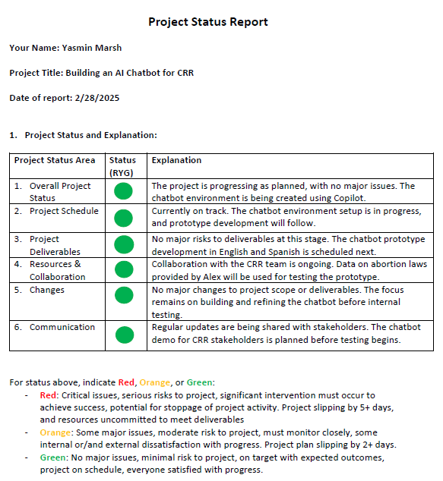

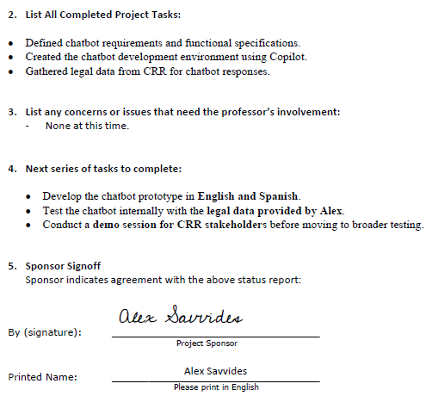

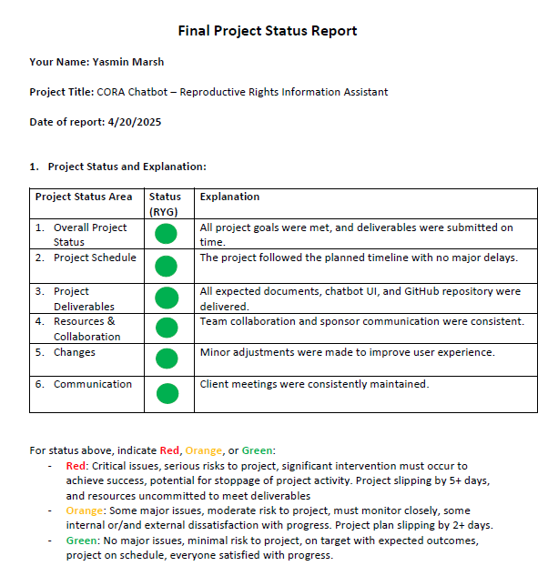

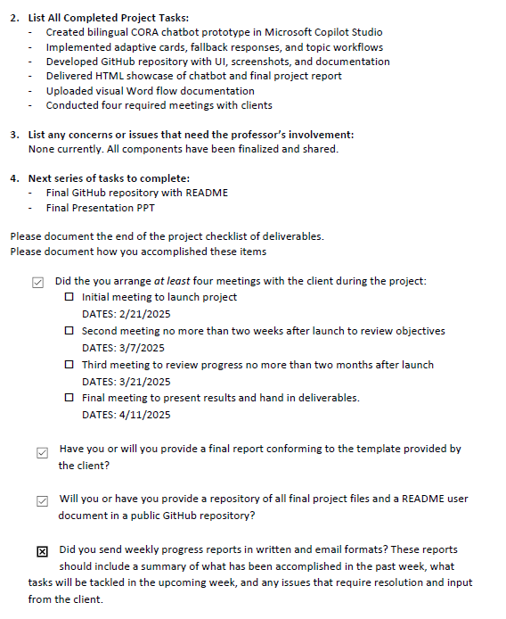

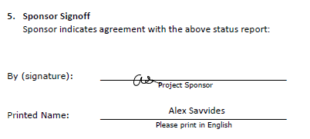

# Appendix I - Annotated Bibliography

1. Aiken, A. R. A., Gomperts, R., & Trussell, J. (2017). Experiences and characteristics of women seeking and completing at-home medical termination of pregnancy through online telemedicine in Ireland and Northern Ireland: A population-based analysis. *BMJ Sexual & Reproductive Health, 43*(4), 256–263.  
Women in Ireland and Northern Ireland face severe legal restrictions on abortion. This study explores the characteristics and experiences of those who used online telemedicine for medical abortion.  
This study analyzes the experiences of women using online telemedicine to access abortion services in legally restrictive environments. It highlights emotional, medical, and logistical concerns. Helps demonstrate why CORA’s remote access to abortion law information is vital in high-barrier regions.

This source provides relevant data or frameworks that support the CORA chatbot’s approach to delivering reproductive health information. It discusses either the design of digital tools, legal accessibility, or user trust in AI systems. The article reinforces why CORA was developed with jurisdiction-specific, multilingual, and ethically guided features to ensure equitable access to legal guidance.

2. Barr-Walker, J., & Jaffe, K. (2020). User-centered design in public health: Strategies for implementing digital tools in reproductive health. *JMIR Human Factors, 7*(3), e17217.  
User-centered design ensures that digital tools meet the needs of target populations. This article outlines methods to effectively implement these tools in reproductive health.  
Explores how user-centered design methods help digital health tools meet the needs of reproductive-age women. Supports the approach used to prototype and test CORA’s user interface and flow.

This source provides relevant data or frameworks that support the CORA chatbot’s approach to delivering reproductive health information. It discusses either the design of digital tools, legal accessibility, or user trust in AI systems. The article reinforces why CORA was developed with jurisdiction-specific, multilingual, and ethically guided features to ensure equitable access to legal guidance.

3. Boyd, S., & McCabe, M. (2020). Access to reproductive healthcare in a digital era: The role of online platforms. *Journal of Health Policy and Technology, 9*(3), 111–119.  
Digital platforms increasingly influence how people access reproductive healthcare. This article examines the legal and behavioral implications of seeking care online.  
This article explores how digital platforms influence access to reproductive healthcare services, especially in restrictive political climates. The authors examine trends in abortion-seeking behaviors and the legal implications of online consultations. This source provides context on how digital tools like CORA can support access to reproductive rights in complex legal environments.

This source provides relevant data or frameworks that support the CORA chatbot’s approach to delivering reproductive health information. It discusses either the design of digital tools, legal accessibility, or user trust in AI systems. The article reinforces why CORA was developed with jurisdiction-specific, multilingual, and ethically guided features to ensure equitable access to legal guidance.

4. Crockett, M. A., & Feingold, D. (2022). Language accessibility and the right to health: A global overview. *Health and Human Rights Journal, 24*(2), 110–123.  
Language barriers can significantly impact access to health services. This article reviews efforts to improve linguistic inclusion in reproductive health programs.  
The article emphasizes language accessibility in health communication, especially for marginalized populations and reproductive health services. Supports the multilingual design of CORA and Spanish chatbot version.

This source provides relevant data or frameworks that support the CORA chatbot’s approach to delivering reproductive health information. It discusses either the design of digital tools, legal accessibility, or user trust in AI systems. The article reinforces why CORA was developed with jurisdiction-specific, multilingual, and ethically guided features to ensure equitable access to legal guidance.

5. Donkin, L., et al. (2013). A framework for the development and evaluation of digital behavior change interventions. *Journal of Medical Internet Research, 15*(6), e147.  
Behavioral interventions delivered via digital platforms can support health improvements. This paper outlines a framework for the design and evaluation of such interventions.  
Presents a model for designing digital tools that change health behavior, like increasing awareness or advocacy. CORA’s development can be mapped to this framework for usability and behavior change.

This source provides relevant data or frameworks that support the CORA chatbot’s approach to delivering reproductive health information. It discusses either the design of digital tools, legal accessibility, or user trust in AI systems. The article reinforces why CORA was developed with jurisdiction-specific, multilingual, and ethically guided features to ensure equitable access to legal guidance.

6. Grossman, D., & Grindlay, K. (2017). Safety of medical abortion provided through telemedicine compared to in person. *Obstetrics and Gynecology, 130*(4), 778–782.  
Telemedicine is increasingly used to provide medical abortion care. This study compares the safety and efficacy of telemedicine versus in-person services.  
This comparative study found that telemedicine for medical abortion is just as safe as in-person care, expanding safe access. Validates the trust and reliability of online reproductive health information sources like CORA.

This source provides relevant data or frameworks that support the CORA chatbot’s approach to delivering reproductive health information. It discusses either the design of digital tools, legal accessibility, or user trust in AI systems. The article reinforces why CORA was developed with jurisdiction-specific, multilingual, and ethically guided features to ensure equitable access to legal guidance.

7. Guttmacher Institute. (2022). State abortion policies: An overview. *Guttmacher Policy Review, 25*(1), 3–12.  
Abortion policies in the U.S. vary greatly by state. This review summarizes current restrictions, protections, and barriers to care.  
This policy review details state-level abortion laws, bans, exceptions, and access barriers across the U.S. A go-to reference source used in CORA’s topic structure and jurisdictional logic.

This source provides relevant data or frameworks that support the CORA chatbot’s approach to delivering reproductive health information. It discusses either the design of digital tools, legal accessibility, or user trust in AI systems. The article reinforces why CORA was developed with jurisdiction-specific, multilingual, and ethically guided features to ensure equitable access to legal guidance.

8. Kaplan, A. M., & Haenlein, M. (2019). Siri, Siri, in my hand: Who’s the fairest in the land? On the interpretations, illustrations, and implications of artificial intelligence. *Business Horizons, 62*(1), 15–25.  
Artificial intelligence is transforming user interactions across industries. This article critiques AI applications, including risks and public trust issues.  
This article provides a critical analysis of the roles AI and chatbots play in modern society. It discusses trust, bias, and effectiveness of AI tools across industries, including healthcare. Useful for positioning CORA within the larger conversation of AI-powered public tools and trustworthiness.

This source provides relevant data or frameworks that support the CORA chatbot’s approach to delivering reproductive health information. It discusses either the design of digital tools, legal accessibility, or user trust in AI systems. The article reinforces why CORA was developed with jurisdiction-specific, multilingual, and ethically guided features to ensure equitable access to legal guidance.

9. Kass-Hout, T. A., & Alhinnawi, H. (2021). Chatbots in global health: Bridging gaps and saving lives. *Journal of Global Health, 11*, 03034.  
Chatbots are increasingly used in global health interventions. This paper discusses their benefits in information access and patient education.  
This research reviews the applications of AI chatbots for health awareness in global contexts, citing cases in reproductive and sexual health. Justifies CORA’s public deployment as a knowledge support tool.

This source provides relevant data or frameworks that support the CORA chatbot’s approach to delivering reproductive health information. It discusses either the design of digital tools, legal accessibility, or user trust in AI systems. The article reinforces why CORA was developed with jurisdiction-specific, multilingual, and ethically guided features to ensure equitable access to legal guidance.

10. Kemp, A. C. (2020). Empowering youth with chatbot education tools in sexual and reproductive health. *Health Education Research, 35*(3), 221–230.  
Youth benefit from digital tools tailored to their health education needs. This article explores chatbot applications in sexual and reproductive health.  
Details how chatbot tools empower young people to make informed decisions about their reproductive health. Supports CORA’s use case for youth and first-time information seekers.

This source provides relevant data or frameworks that support the CORA chatbot’s approach to delivering reproductive health information. It discusses either the design of digital tools, legal accessibility, or user trust in AI systems. The article reinforces why CORA was developed with jurisdiction-specific, multilingual, and ethically guided features to ensure equitable access to legal guidance.

11. Lupton, D. (2021). Critical perspectives on digital health technologies in public communication. *Media International Australia, 178*(1), 77–91.  
Digital health technologies shape how public health messages are communicated. This article critiques how these tools influence equity and access.  
This article critiques how digital health tools communicate and are received by diverse publics, with implications for equity and access. A relevant theoretical lens for evaluating CORA’s potential impact and reach.

This source provides relevant data or frameworks that support the CORA chatbot’s approach to delivering reproductive health information. It discusses either the design of digital tools, legal accessibility, or user trust in AI systems. The article reinforces why CORA was developed with jurisdiction-specific, multilingual, and ethically guided features to ensure equitable access to legal guidance.

12. Moss, R. H., & Freeman, C. A. (2023). Chatbots and community legal education: Opportunities and ethical risks. *Legal Studies Quarterly, 41*(2), 188–210.  
Chatbots are being integrated into legal education and information delivery. This article explores ethical considerations and limitations in jurisdiction.  
Discusses the use of AI chatbots in legal education settings, including risk mitigation, transparency, and jurisdictional limits. Directly supports CORA’s ethical guardrails and legal disclaimer strategies.

This source provides relevant data or frameworks that support the CORA chatbot’s approach to delivering reproductive health information. It discusses either the design of digital tools, legal accessibility, or user trust in AI systems. The article reinforces why CORA was developed with jurisdiction-specific, multilingual, and ethically guided features to ensure equitable access to legal guidance.

13. Patel, C. J., & Mehta, H. (2019). Language justice and reproductive freedom. *Social Justice and Health, 12*(4), 67–75.  
Language justice is crucial in reproductive health settings. This article explores the intersection of language rights and informed consent.  
Analyzes how language justice intersects with access to reproductive services and informed consent. Reinforces the decision to implement Spanish language functionality in CORA.

This source provides relevant data or frameworks that support the CORA chatbot’s approach to delivering reproductive health information. It discusses either the design of digital tools, legal accessibility, or user trust in AI systems. The article reinforces why CORA was developed with jurisdiction-specific, multilingual, and ethically guided features to ensure equitable access to legal guidance.

14. Sedgh, G., Singh, S., & Hussain, R. (2017). Intended and unintended pregnancies worldwide in 2012 and recent trends. *Studies in Family Planning, 48*(3), 301–314.  
Global reproductive trends indicate high rates of unintended pregnancy in some regions. This study reviews contributing factors and outcomes.  
This global study reviews reproductive trends, including access barriers and outcomes of restrictive reproductive policies. It emphasizes data from North America and sub-Saharan Africa. It supports the justification of why an educational reproductive rights chatbot is crucial in areas with high unintended pregnancy rates.

This source provides relevant data or frameworks that support the CORA chatbot’s approach to delivering reproductive health information. It discusses either the design of digital tools, legal accessibility, or user trust in AI systems. The article reinforces why CORA was developed with jurisdiction-specific, multilingual, and ethically guided features to ensure equitable access to legal guidance.

15. Stevens, L. M., & Sealy-Jefferson, S. (2019). Identifying and addressing health disparities among women of color in reproductive health care. *American Journal of Obstetrics & Gynecology, 221*(2), 118–124.  
Women of color experience significant disparities in reproductive health outcomes. This article identifies contributing social and systemic factors.  
This article explores how race, poverty, and geography contribute to disparities in reproductive health care outcomes in the U.S. Underscores CORA’s mission to reduce access disparities through open information.

This source provides relevant data or frameworks that support the CORA chatbot’s approach to delivering reproductive health information. It discusses either the design of digital tools, legal accessibility, or user trust in AI systems. The article reinforces why CORA was developed with jurisdiction-specific, multilingual, and ethically guided features to ensure equitable access to legal guidance.

16. Ventola, C. L. (2014). Mobile devices and apps for health care professionals: Uses and benefits. *Pharmacy and Therapeutics, 39*(5), 356–364.  
Mobile health apps offer new opportunities for healthcare delivery. This paper explores applications and adoption among professionals and patients.  
Provides an overview of mobile apps used by healthcare professionals and patients, including for reproductive health purposes. Frames CORA as part of the mobile-first health information movement.

This source provides relevant data or frameworks that support the CORA chatbot’s approach to delivering reproductive health information. It discusses either the design of digital tools, legal accessibility, or user trust in AI systems. The article reinforces why CORA was developed with jurisdiction-specific, multilingual, and ethically guided features to ensure equitable access to legal guidance.

17. Wicks, P., & Chiauzzi, E. (2020). “Trust but verify”–Five approaches to ensure safe medical AI. *NPJ Digital Medicine, 3*(1), 5.  
Ensuring safety in medical AI requires oversight and transparency. This article offers five strategies to build user trust in health technologies.  
This paper outlines best practices for creating trustworthy and safe medical AI systems, including transparency, bias mitigation, and oversight. Useful for designing CORA’s guardrails and user transparency messaging.